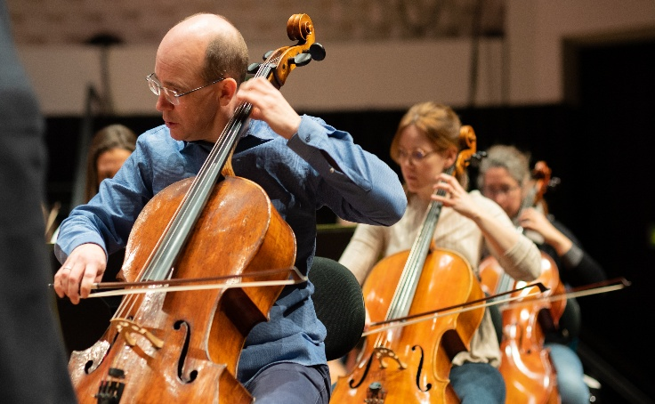
Tutti Cello
Information for Applicants
Spring 2026

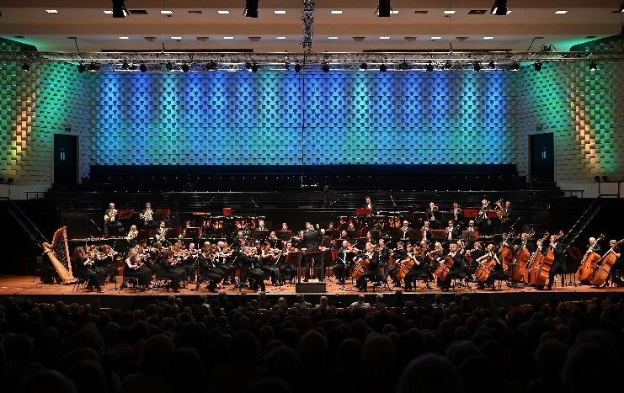
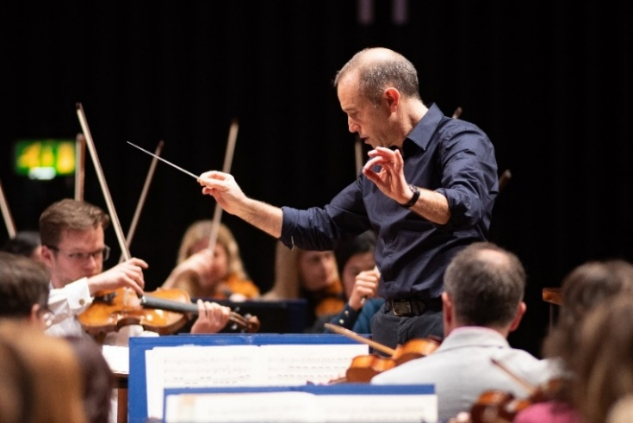

About Bournemouth Symphony Orchestra
‘The cultural heartbeat of the South West.’ Darren Henley, Chief Executive of Arts Council England
One of the UK’s best-loved orchestras, Bournemouth Symphony Orchestra is known for championing the role of culture in people’s lives. Based at Lighthouse, Poole, the Orchestra is resident in Bristol, Exeter, Portsmouth, Southampton, and Yeovil, and performs in towns and villages across the region. A leading arts charity, it is the largest performing organisation in the South West of England, serving one of the biggest and most diverse regions in the UK.
Celebrated globally for his outstanding musicianship and extraordinary interpretations, Mark Wigglesworth’s first season as Chief Conductor magnified the BSO’s reputation for the highest quality music-making. The Orchestra boasts an enviable list of named conductors, including Principal Guest Conductor Chloé Van Soeterstède, Marin Alsop, David Hill MBE, Kirill Karabits and Andrew Litton. In 2025/26, the BSO welcomed baritone Roderick Williams OBE as Artist-in-Residence and introduced Dani Howard as its Celebrated Composer. Its pioneering Digital Concert series continues into its sixth year, with 19 live performances broadcast globally.
Known for championing access to high-quality music for all, the BSO leads hundreds of community-based events each year, from award-winning work in health and care settings to partnerships with schools and music education hubs.
For further information about the BSO please visit bsolive.com

Living in the South West
Dorset has 364 more hours of sunshine throughout the year in comparison to the UK average.

With two Oscar winning Universities, Bournemouth has one of the fastest growing tech sectors in the UK.

Voted the best place to live in the UK in 2014 with miles and miles of sandy beaches, some of the best weather in the UK and the longest life expectancy in Britain, Dorset makes for a happy home. With over half the county designated as an Area of Outstanding Natural Beauty, no one can deny that Dorset is truly something special. The county also boasts 5 country parks too. Brownsea Island in Poole Harbour was voted Britain’s favourite nature reserve in 2013 and the area around Wareham is recognised as the most botanically rich in the UK.
Dorset has nearly 100 miles of coastline with award winning, golden sandy beaches and Dorset’s great outdoors provides a green gym, which is simply unrivalled in the UK.
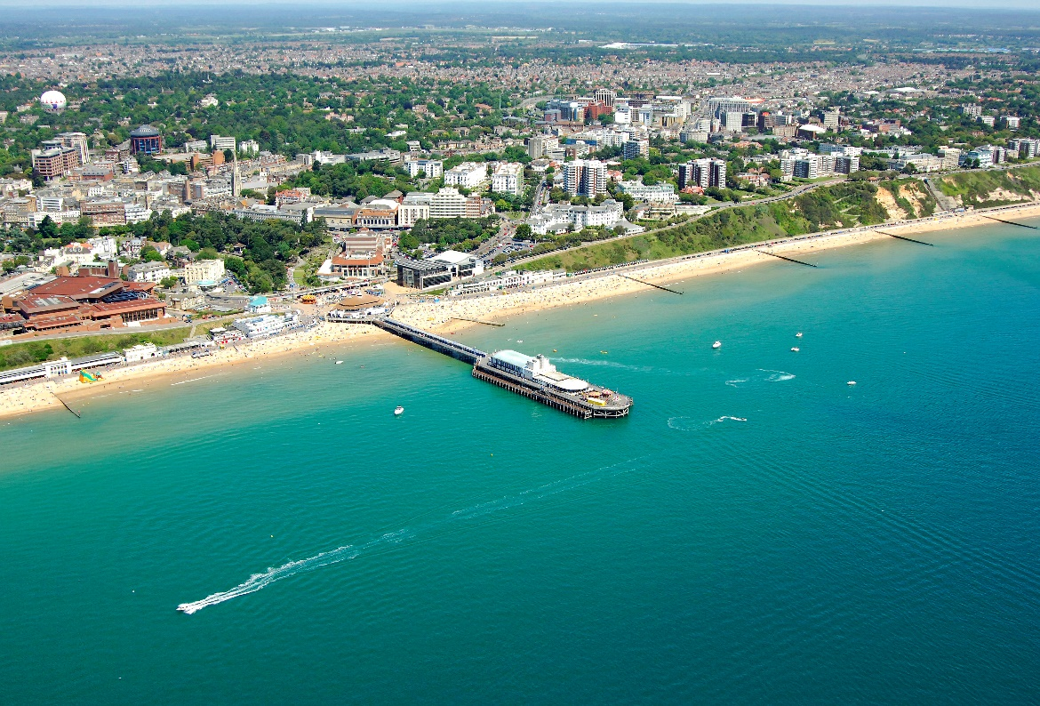

Employee Benefits
- Annual leave entitlement of 42 days plus bank holidays.
- Personal Pension with an employer contribution and the option of salary exchange.
- Instrument Insurance, through Lark Music.
- Access to the BSO’s health and wellbeing programme including weekly yoga classes.
- Medical cover from Bupa, a cash plan scheme providing money for a large range of treatments including £300 a year for physiotherapy/Chiropractic treatments.
- Life Insurance which provides a life cover of 3 times salary.
- 1 hour of free legal advice and 50% discount on Will writing and estate planning services
- Complimentary or reduced-price tickets to BSO concerts and theatre/cinema at the Lighthouse when available.

