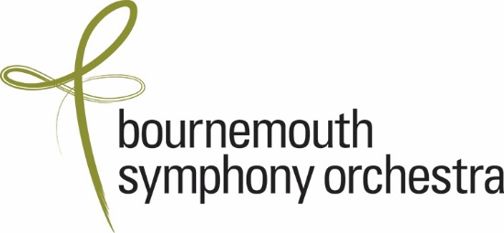

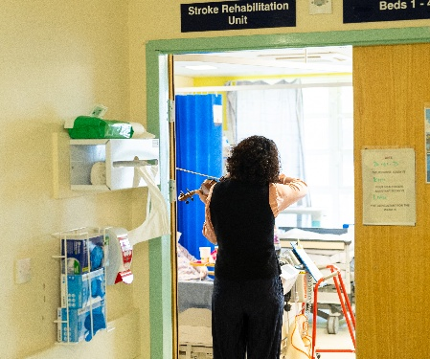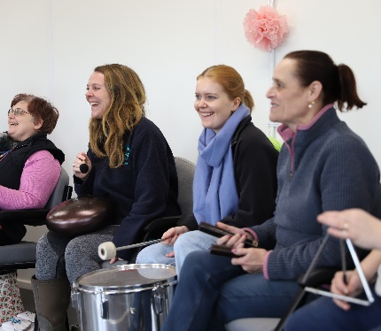

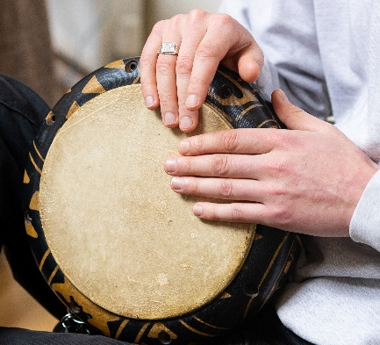
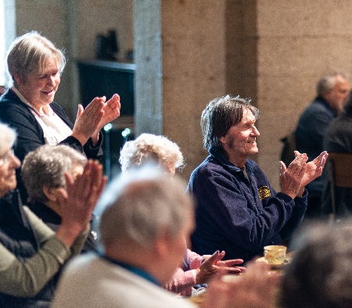
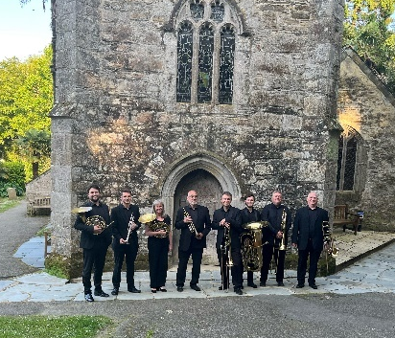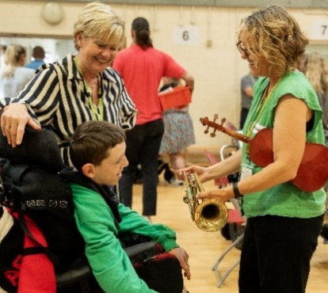

Projects Coordinator, BSO Participate
Job Pack, March 2026

- Job Description
- Person Specification
- About the BSO and BSO Participate
- How to Apply

- Job Description
Projects Coordinator , BSO Participate
Salary: £23,000 - £25,000 per annum depending on experience
Hours: Full time (32.5 hours/ week including occasional evening and weekend events and projects)
Location: Poole, with travel around Southwest for projects (in BSO company cars)
Report to: Senior Programme Manager (Creative Health and Communities)
Employee benefits include:
- Annual leave entitlement of 28 working days including bank holiday plus discretionary quota of leave between Christmas and New Year, increasing to 30 days after two years of employment.
- Personal Pension with an employer contribution (5%) and the option of salary exchange
- Generous Life Insurance which provides a life cover of 3 times salary
- 1 hour of free legal advice and 50% discount on Will writing and estate planning services
- Medical cover with Bupa Cash Plan
- Complimentary tickets to BSO concerts and theatre/cinema at the Lighthouse when available
- Free car parking close to BSO head office at Poole, Lighthouse
- Personal goal setting and development opportunities through a personalised learning & development plan and performance review. Mentoring in project management and skills development, and access to networking opportunities at sector events and conferences.
- Opportunity to be part of the Diversity Champions or BSO Green Team to drive forward our commitment to Equality, Diversity and Inclusion and the Environment, or a Mental Health First Aider.
Key relationships
Head of BSO Participate, Senior Programme Managers and Coordinators, Participate Administrator, BSO Associates, Orchestra and freelance musicians,
Role summary
The Coordinator will work closely with the Senior Programme Manager on BSO’s vibrant programme of Creative Health and Community and support the full output of the Participate department. The role will include work from the Head Office in Poole and travelling to projects across the South West, supporting creative teams, partners and participants of all ages and in a range of settings to connect with the unique power of music to transform lives.

Main Responsibilities
- Lead on the coordination of Creative Health programmes including 7 regional year-round Recovery, Wellbeing and Community Orchestras and a growing programme of music in hospitals, to include
  - Scheduling and briefing musicians
  - Planning equipment logistics
  - Supporting planning with Associate music leaders
  - Liaising with cross-sector partners on the coordination, briefing and evaluation of programmes
  - Collecting and processing of monitoring and evaluation data for all programmes
- Coordinate event delivery for specific Creative Health and Community events, and support on other Participate events where required
- Support the Senior Programme Managers and Head of Department on the scheduling and coordination of future programmes
- Be a key contact for and positive advocate of the Creative Health and Communities programme and wider BSO Participate work both internally and externally

Administration, Evaluation, Advocacy and Digital
- Create events, manage records and log information to ensure accurate record keeping on Spektrix, the Participate diary, OPAS (Orchestral Planning software), fee sheets and attendance records
- Monitor events and projects, including data management with participants, artists, audiences and partners
- Collate feedback and monitoring data for key stakeholders, and identify learnings, case studies and stories from across the Programme
- Work with BSO marketing/communications to publicise BSO Participate events, and feature projects in internal and external communications, including keeping BSO Participate pages up to date on the website
- Work with the Senior Programme Manager to keep all relevant partners and stakeholders informed about projects and the wider work of BSO Participate
- Assist with BSO Participate programme enquiries through phone, email and in person

General
- Support the BSO Participate team in all aspects of the programme, assisting with larger projects and events where required
- Carry out other duties as required

- Person Specification
Experience
Experience organising, planning and delivering projects and events
Experience and knowledge of music/performing arts
Experience of working or volunteering in an arts organisation
Experience working with vulnerable adults and young people
Understanding of safeguarding
Experience working inclusively and applying the social model of disability (desirable)

Skills
Excellent organisational skills with high level of attention to detail
Ability to prioritise multiple workstreams and hit deadlines
Excellent standard of literacy and numeracy
Excellent verbal communication skills
Excellent computer skills (Excel, Word, email, learning new systems)

Personal Attributes
A passion for participation and the role of music in enhancing people’s quality of life
A passion for working with partners across sectors, including health & community
A team player who thrives in working with others and can anticipate need
Confident engaging with and supporting a range of people from diverse
backgrounds sensitively and inclusively, from participants to artists & musicians
Highly motivated and proactive .
Enjoys a mix of desk-work and on-project event delivery coordination

General
Availability and willingness to work occasional weekends and evenings
when required
Current clean UK drivers licence

- About the BSO and BSO Participate
Championing culture in people’s lives
One of the UK’s best-loved orchestras, Bournemouth Symphony Orchestra is known for championing the role of culture in people’s lives. Based at Lighthouse, Poole, the Orchestra is resident in Bristol, Exeter, Portsmouth, Southampton, and Yeovil, and performs in towns and villages across the region. It is the largest cultural provider in the Southwest of England, serving one of the biggest and most diverse regions in the UK.
Mark Wigglesworth’s appointment as Chief Conductor builds on the BSO’s reputation for the highest quality music-making; the Orchestra boasts an enviable list of named conductors, including Principal Guest Conductor Chloé van Soeterstède, Marin Alsop, David Hill MBE, Kirill Karabits, and Andrew Litton.
BSO Participate positively impacts the lives of people living across the 10,000 square miles of the Southwest of England. Every year, the BSO’s award-winning programme creates over 50,000 opportunities for people throughout the life span from parents and babies to people at the end of life to experience, learn and create music – building connections, improving health & wellbeing and enriching creativity and learning.
With inclusion at the heart of all our work we actively challenge barriers to music, working with a wealth of specialist partners and a network of BSO Associate music leaders across the South West.
You will be joining a passionate and dedicated BSO Participate team - from our Head Office to our network of music leaders and musicians across the Southwest, in continuing to be at the forefront of championing access to high-quality music. Working with people of all ages including families, people experiencing mental health challenges, people living with dementia, patients and staff in hospitals and residents and staff in care homes, you will be part of a team committed to ensuring that music is part of people’s lives right across the South and South West.
We’re looking for someone with the right potential, for a role that is full of opportunity to make a mark as part of a pioneering programme.

The BSO is committed to equal opportunities and highly values diversity in its workforce.
We actively welcome applications from individuals with backgrounds currently underrepresented in the arts. We acknowledge the barriers that exist and are committed to providing equal opportunities. We believe that having a diverse workforce strengthens the work we do. We are proud to be recognised as a Disability Confident employer and are committed to making reasonable adjustments in the recruitment process and in the role.

- How to Apply
Please visit https://bsolive.com/jobs/ and complete the online application form and send to us with a cover letter referencing the Job Description and Person Specification.
Deadline for applications is 9am Monday 20 April 2026
Interviews to be held in Poole on Monday 27 - Wednesday 29 April 2026. If successful second round interviews will be held shortly afterwards. Interview questions can be provided in advance if successful.
If you would like more information or a friendly confidential chat about any aspect of the job before applying, please contact Sue Sharpe ssharpe@bsorchestra.co.uk to arrange a phone call.
If you need any of the application documents in a different format or have any questions about or need support with the application process, please also get in touch.
The BSO is committed to safeguarding through safer recruitment. All our roles require the successful candidate to complete a Disclosure and Barring Check, the receipt of satisfactory references and be eligible to work in the UK.

