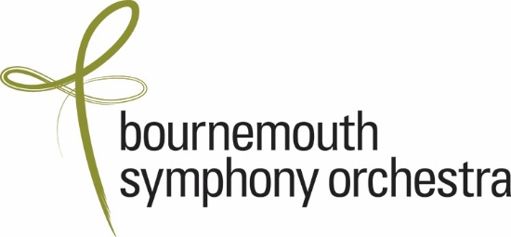



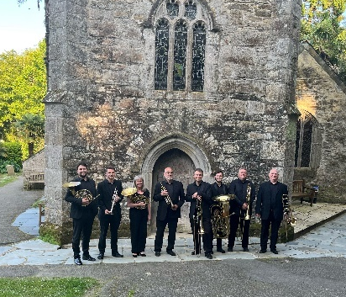



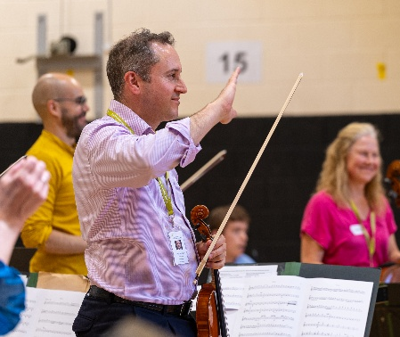
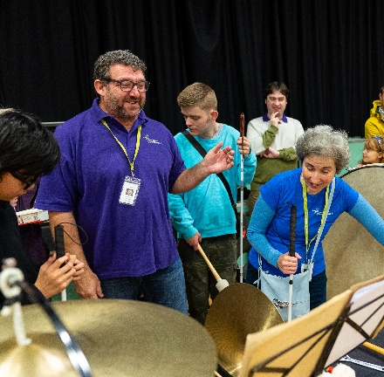



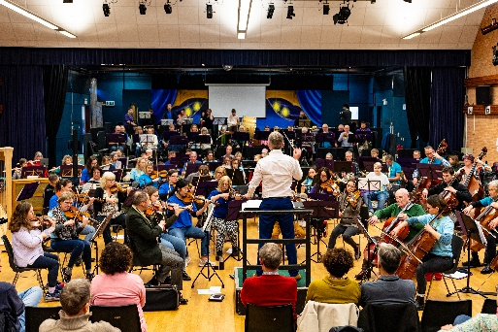

BSO Participate Producer
Job Pack, January 2026

- About the BSO and BSO Participate
- Job Description
- Person Specification
- Terms and Conditions
- How to Apply

- About the BSO and BSO Participate
One of the UK’s best-loved orchestras, Bournemouth Symphony Orchestra is known for championing the role of culture in people’s lives. Based at Lighthouse, Poole, the Orchestra is resident in Bristol, Exeter, Portsmouth, Southampton, and Yeovil, and performs in towns and villages across the region. It is the largest cultural provider in the Southwest of England, serving one of the biggest and most diverse regions in the UK.
BSO Participate positively impacts the lives of people living across the 10,000 square miles of the Southwest of England. Every year, the BSO’s award-winning programme creates over 50,000 opportunities for people throughout the life span from parents and babies to people at the end of life to experience, learn and create music – building connections, improving health & wellbeing and enriching creativity and learning.
With inclusion at the heart of all our work we actively challenge barriers to music, working with a wealth of specialist partners and a network of BSO Associate music leaders across the South West;
- We ensure children and young people have access to the holistic benefits of music in education, through our interactive schools concerts in mainstream and SEND settings and bespoke in-school projects
- We promote the diversity of opportunity for young people in the orchestral sector, with our Young Associates programme providing a career springboard and continued professional development for emerging music leaders under-represented in music.
- We drive positive change in the improvement of people’s health and quality of life, with seven regional Community and Recovery Orchestras, music in hospital programmes, and tailored performances in care and community settings
- We strengthen local communities through shared live music experiences, from BSO’s On Your Doorstep of smaller scale performances in the heart of local communities, to our tailored dementia-friendly Cake Concerts

You will be joining a passionate and dedicated BSO Participate team - from our Head Office to our network of music leaders and musicians across the Southwest, in continuing to be at the forefront of championing access to high-quality music. Working as part of the BSO Participate Head Office team in Poole, you will work closely with colleagues across the organisation and with BSO orchestral and freelance musicians, in a new role strengthening and developing our ensemble music making and performance programmes impacting thousands of people every year.

- Job Description
Role summary
The BSO Participate Producer is an exciting new role managing BSO’s diverse regional performance programmes and inclusive ensemble music-making initiatives. The role is ideal for an ambitious producer with a belief in the transformative power of music to enhance community, who is driven by a commitment to access and inclusion, and has strong experience of programme and event management.
In this hands-on role, you will shape and deliver a dynamic programme of performances across the South and South West including BSO On Your Doorstep and Cake Concerts in village halls, regional theatres, churches and community spaces, connecting with local audiences of all ages, young families, schools and SEND young people, and people living with dementia and their carers.
As a critical member of the Participate team and working closely with the Concerts department, you will cultivate strong and positive relationships with BSO musicians including with BSO Resound, and you will be a leading figure in BSO’s pioneering inclusive side by side programme Symphony from Scratch, and support BSO’s National Open Youth Orchestra ensemble amongst other inclusive ensemble music-making initiatives.

Key relationships
Head of BSO Participate; Senior Programme Managers; Participate Administrator and Coordinators, Concerts Manager; Orchestra Managers, Music Library, BSO Resound, Orchestral and freelance musicians.

The role will be the first point of contact internally and externally for all BSO small-mid scale programmes and ensembles. With inclusion and access at the heart , key responsibilities will include:
- Managing an annual programme of BSO On Your Doorstep performances to include:
  - Lead on programming performances with a variety of external partners including Rural Touring Agencies, regional and community venues, churches and abbeys and others
  - In close partnership with the Concerts Manager, schedule performances according to availability of Orchestra
  - With Head of Participate and in dialogue with BSO musicians, liaise with BSO library to curate new high quality and high appeal programmes for diverse audiences
- Leading on the planning, development, delivery and continued evaluation of Symphony from Scratch to include:
  - Facilitate ongoing dialogue with young musicians, BSO Resound members, and local amateur musicians in the continuous design and development of the programme
  - Work with internal cross-department colleagues to schedule, programme and produce the programme, meeting the diverse needs of all stakeholders, including the coordination of adapted parts for participants, stage plans in collaboration with stage managers, access riders for participants
  - Manage the event days, with BSO Participate colleagues, and lead on internal reflection and evaluation
- Supporting BSO ensemble rehearsals and development, in particular BSO Resound, to include managing musicians’ schedules, accommodation, and travel, ensuring all access needs are met at every stage in preparation and throughout event days
- Support and/ or lead on other BSO ensemble related activity include NOYO performances, dementia friendly Cake Concerts, school concerts and Family & Relaxed shows.

Advocacy, Administration & Evaluation
- Champion Access and Inclusion throughout all of BSO’s output and practice, and innovate to ensure best practice and influence positive change
- Forecast budgets and maintain and monitor income and expenditure of key programmes
- Create and ensure compliance with Risk Assessments, and ensure all Safeguarding procedures are understood and met
- Monitor and evaluate events and projects, including data management with participants, artists, and audiences.
- Collate evaluation and circulate data to key stakeholders, and identify learnings, case studies and stories from key programmes and initiatives
- Create events, manage records and log information to ensure accurate record keeping using Spektrix (ticketing software), OPAS (Orchestral management software), Dot Digital and online calendars
- Work with the Head of Department to keep all relevant partners and stakeholders informed about particular projects and wider work of BSO Participate.

General
- Support the BSO Participate team in all aspects of the programme, assisting with larger projects and events where required
- Assist with BSO Participate programme enquiries through phone, email and in person.
- Represent BSO internally and externally in meetings and events where necessary

- Person Specification
Personal Attributes
Strong commitment to BSO’s mission with a passion for the transformative power of music for performers and communities
Values-led, inclusive and actively committed to access and inclusion in ensemble music making
Able to work flexibly and responsively to developing needs and agendas, with sound judgement in live delivery settings
Highly motivated and proactive with a passion to innovate
Collaborative and person-centred, thriving in building strong relationships with colleagues, musicians and external partners and stakeholders
Experience
Minimum 3 years experience of end-to-end producing/ managing in an arts setting including planning, delivering and evaluating performance programmes
Strong track record of event management
Experience of working with professional artists/musicians in a leadership role
Experience of working with a contract orchestra (desirable)
Experience of working with accessible electronic musical instruments (desirable)
Skills
Excellent written and spoken communicator with a proven understanding of meeting diverse access needs
Musician or background in music with an at least basic ability to read written music and understanding of creative music-making
Comprehensive and up to date knowledge of best practice in inclusive music-making
Excellent IT/ digital skills

General
Availability and willingness to work weekends and evenings when required
Current clean UK drivers licence

- Terms and Conditions
Salary: £28 - £32k
Hours: Full time with part-time considered. Includes some evening and weekend work at events
Location: Poole, with travel around Southwest for projects.
Report to: Head of BSO Participate
Employee benefits include:
- Annual leave entitlement of 28 working days including bank holiday plus discretionary quota of leave between Christmas and New Year, increasing to 30 days after two years of employment.
- Personal Pension with an employer contribution (5%) and the option of salary exchange
- Generous Life Insurance which provides a life cover of 3 times salary
- 1 hour of free legal advice and 50% discount on Will writing and estate planning services
- Medical cover with Bupa Cash Plan
- Complimentary tickets to BSO concerts and theatre/cinema at the Lighthouse when available
- Free car parking close to BSO head office at Poole, Lighthouse
- Personal goal setting and development opportunities through a personalised learning & development plan and performance review. Mentoring in project management and skills development, and access to networking opportunities at sector events and conferences.
- Opportunity to be part of the Diversity Champions or BSO Green Team to drive forward our commitment to Equality, Diversity and Inclusion and the Environment, or a Mental Health First Aider.

The BSO is committed to equal opportunities and highly values diversity in its workforce.
We actively welcome applications from individuals with backgrounds currently underrepresented in the arts. We acknowledge the barriers that exist and are committed to providing equal opportunities. We believe that having a diverse workforce strengthens the work we do. We are proud to be recognised as a Disability Confident employer and are committed to making reasonable adjustments in the recruitment process and in the role.

- How to Apply
Please visit https://bsolive.com/jobs/ and complete the online application form and send to us with a cover letter referencing the Job Description and Person Specification.
No fixed deadline – we will be assessing applications and inviting to interview on a rolling basis.
Interview questions can be provided in advance if requested. If you need any of the application documents in a different format or have any questions about or need support with the application process, please also get in touch.

If you would like more information or a friendly confidential chat about any aspect of the job before applying, please contact Head of BSO Participate Lucy Warren lwarren@bsorchestra.co.uk to arrange a phone call.
The BSO is committed to safeguarding through safer recruitment. All our roles require the successful candidate to complete a Disclosure and Barring Check, the receipt of satisfactory references and be eligible to work in the UK.

