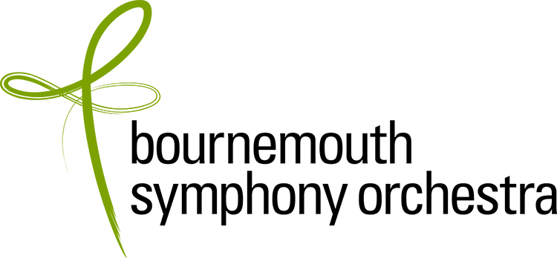

AUDITION APPLICATION FORM

Applications should be emailed to Charlotte Oxberry: coxberry@bsorchestra.co.uk
Please complete all sections of the form

Data Protection: The information that you have given in this form will be held for recruitment purposes only and will not be disclosed outside the BSO without your permission.

POSITION APPLIED FOR | Tutti 1st Violin

CLOSING DATE FOR APPLICATIONS: 9 June 2025 9:00AM
(Applications received after the closing date may be considered at the Company’s discretion)

First name |  | Title
Surname

PERSONAL DETAILS (please complete all sections)
Full home address including city
Postcode |  | Country
Phone / mobile |  | Diary Service (if applicable)
Email |  | National Insurance Number
Nationality |  | Do you hold a UK passport? | Yes / No  (Important: If “no passport” you must provide details of Settled Status using the UK government website: https://www.gov.uk/prove-right-to-work , plus your date of birth, or state “NO VISA”) Without this information we cannot proceed with your application.
Have you ever been convicted of a criminal offence, other than motoring offences & spent convictions?  (declaration subject to the Rehabilitation of Offenders Act 1974) |  | Yes / No
BSO is committed to equality & diversity in employment. If you have any accessibility requirements please tell us about the adjustments we need to make to assist you at audition.

AUDITION APPLICATION: Education and Experience (this section is sent separately to the panel, hence a further request for your name and the position for which you are applying)

Full name:

Position applied for: | Tutti 1st Violin

ORCHESTRAL EXPERIENCE
Please list details of your orchestral experience, stating position where applicable.
Please start with the most recent and include dates.
Orchestra | Position (if applicable) | Dates

MUSICAL EDUCATION AND TRAINING

Institution | Study/degree course | Dates | Qualification obtained

TEACHERS

Name | Dates

ADDITIONAL INFORMATION

Please use this space to provide any additional information that is relevant to your application e.g. details of solo/chamber music performances, master classes, competitions etc.

Date  (if known) | Additional information

How did you hear about this vacancy? Please tick all that apply.
Musicalchairs ☐
BSO Website ☐
BSO Instagram ☐
BSO Twitter ☐
BSO Facebook ☐
BSO LinkedIn ☐
Word of Mouth ☐

Other (please specify) ☐

Declaration:

- If you are offered the position, you will be required to complete a medical questionnaire.

- On taking up your post you will be required to undergo a hearing check as part of the induction process.

- If you are offered the position, you will be required to undergo a DBS (Disclosure & Barring Service) check.

- Do not include a CV with your application.

I can confirm that to the best of my knowledge the above information is correct. I accept that deliberately providing false information could result in my dismissal.

Name:
Date:

Note: If you are not a UK passport holder, please include a copy your passport with your application and details of Settled Status if applicable. If you do not have a visa it is helpful that we know this at this early stage.

