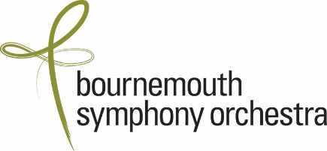

CONFIDENTIAL: EQUAL OPPORTUNITIES MONITORING FORM
We are committed to developing positive policies to promote equal opportunities in employment and prohibiting unlawful discrimination on the grounds of age, sex, gender reassignment, marital or civil partnership status, pregnancy & maternity, race, disability, sexual orientation and religion or belief.

In order to ensure that these policies are being followed, and for no other purpose, all applicants are asked to provide the following information, which will be treated in the strictest confidence and will only be used for statistical monitoring purposes. The information will not form part of the selection process

If you have any questions concerning this please contact Jenny Wingfield: jwingfield@bsorchestra.co.uk

Position applied for: ASSISTANT ORCHESTRA MANAGER

Age: Please tick to which age group you belong:

Under 25 ☐ 25-34 ☐ 35-49 ☐ 50-64 ☐ 65+ ☐ Prefer not to say ☐

Gender: Female (including trans women) ☐ Male (including trans men) ☐
Non-binary (androgyne) ☐ Prefer not to say ☐

Sexual Orientation: Bisexual ☐ Gay Man ☐ Gay Woman / Lesbian ☐
Heterosexual / Straight ☐ Queer ☐ Prefer not to say ☐

Please tick which ethnic group you belong to:
White (British, Irish, Gypsy or Irish Traveller, or other white background) ☐
Mixed (White and Black Caribbean, White and Black African, White and Asian or
any other mixed background) ☐
Asian or Asian British (Indian, Pakistani, Bangladeshi or any other Asian background) ☐
Black or Black British (Caribbean, African or any other Black background) ☐
Chinese ☐
Any other ethnic group ☐
Prefer not to say ☐

Please select one of the following:
I identify as a deaf or disabled person, or have a long term health condition ☐
I do not identify as a deaf or disabled person, or have a long term health condition ☐
I prefer not to say ☐

