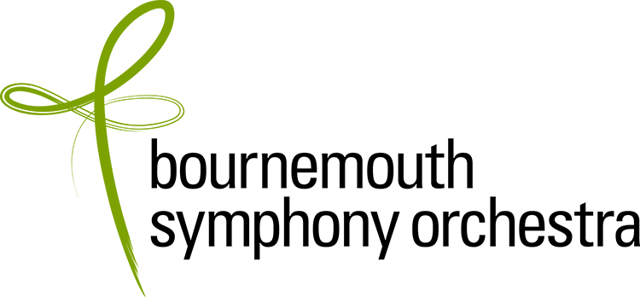

AUDITION APPLICATION FORM

Applications should be emailed to: ecarr@bsorchestra.co.uk Please complete all sections

Data Protection: The information that you have given in this form will be held for recruitment purposes only and will not be disclosed outside the BSO without your permission.

POSITION APPLIED FOR | Principal Viola – Section Leader: 2024

CLOSING DATE FOR APPLICATIONS: this has been left open intentionally. BSO reserve the right to close the process in the event of finding the best candidate for the position. Early applications are therefore advised.

First name |  | Title
Surname

PERSONAL DETAILS (please complete all sections)
Full home address including city
Postcode |  | Country
Phone / mobile |  | Diary Service (if applicable)
Email |  | National Insurance Number
Nationality |  | Do you hold a UK passport? | Yes / No  (If “no” please provide a copy of your passport and details of Settled Status if applicable, or say “NO VISA”)
Have you ever been convicted of a criminal offence, other than motoring offences & spent convictions?  (declaration subject to the Rehabilitation of Offenders Act 1974) |  | Yes / No
BSO is committed to equality & diversity in employment. If you have any accessibility requirements please tell us about the adjustments we need to make to assist you at audition.

AUDITION APPLICATION: Education and Experience (this section will be sent separately to the panel, hence a further request for your name and the position for which you are applying)

Full name:

Position applied for: | Principal Viola – Section Leader: 2024

ORCHESTRAL EXPERIENCE
Please list details of your orchestral experience, stating position where applicable.
Please start with the most recent and include dates.
Orchestra | Position (if applicable) | Dates

MUSICAL EDUCATION AND TRAINING

Institution | Study/degree course | Dates | Qualification obtained

TEACHERS

Name | Dates

ADDITIONAL INFORMATION

Please use this space to provide brief details of any additional information that is relevant to your application e.g. solo/chamber music performances, master classes, competitions, etc.

How did you hear about this vacancy? Please tick all that apply.
Musicalchairs ☐
BSO Website ☐
BSO Instagram ☐
BSO Twitter ☐
BSO Facebook ☐
BSO LinkedIn ☐
Word of Mouth ☐

Other (please specify) ☐

Declaration:

- If you are offered the position you will be required to complete a medical questionnaire.

- On taking up your post you will be required to undergo a hearing check as part of the induction process.

- If you are offered the position you will be required to undergo a DBS (Disclosure & Barring Service) check.

- Please do not include a CV with your application.

I can confirm that to the best of my knowledge the above information is correct. I accept that deliberately providing false information could result in my dismissal.

Name:
Date:

Note: If you are not a UK passport holder, please include a copy your passport with your application and details of Settled Status if applicable. If you do not have a visa it is important that we know this at this early stage.

