Principal Horn (Section Leader)
Information for Applicants
Spring 2023
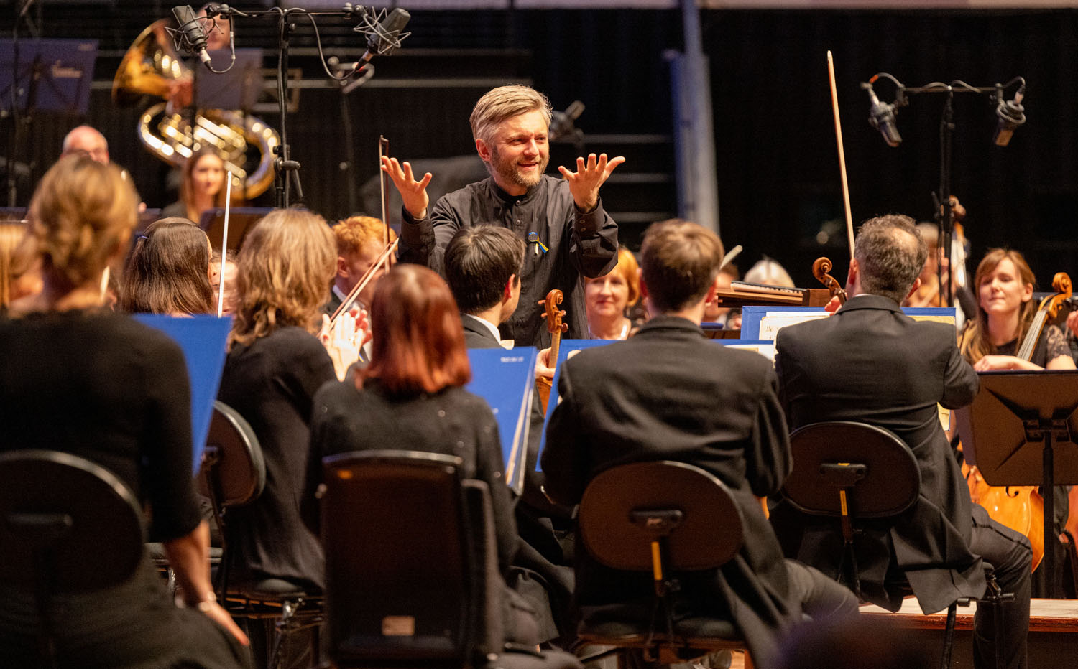

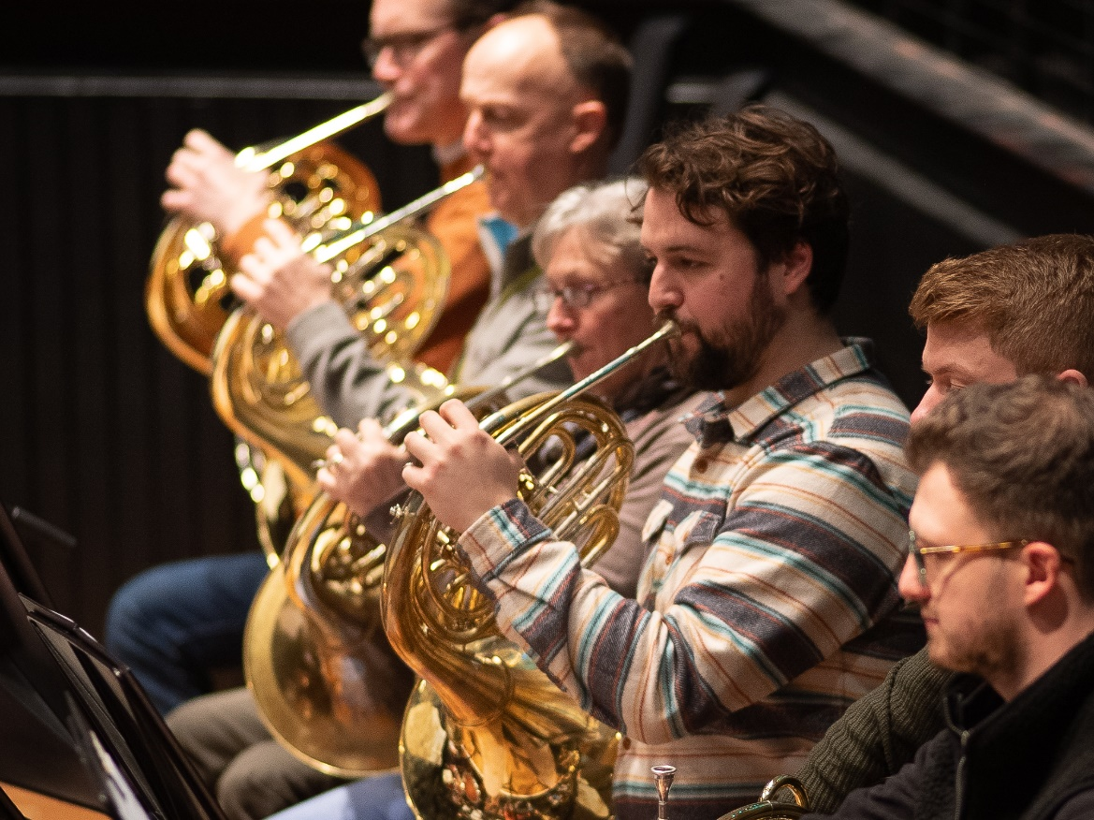

About Bournemouth Symphony Orchestra
‘The cultural heartbeat of the South West.’ Darren Henley, Chief Executive of Arts Council England
Since 1893, Bournemouth Symphony Orchestra has represented artistic excellence. Throughout its illustrious history, BSO has worked with the finest composers, conductors and musicians in the world.
As an Orchestra, BSO’s reach is exceptional. In the 2018/19 concert season, In a pre-pandemic season BSO would normally give 130 performances in over 38 cities, towns and villages, making it the most prolific orchestra in the UK and one of the most prolific in the world. BSO performs to 5,000 audience members a week through its main venue concerts.
The Orchestra’s music making headquarters is based at Lighthouse, Poole’s Centre for the Arts, Dorset, where it delivers around 40 performances a year. Three-quarters of its artistic output is exported and performed across the length and breadth of the UK.
BSO attracts significant praise for its artistic output. The Telegraph wrote, ‘No other regional British orchestras - few London ones, for that matter- offer more interesting programming than the Bournemouth Symphony Orchestra.’
The BSO was one of the very first UK orchestras to resume live performance after the initial COVID-19 lockdown. Our trail-blazing response throughout the pandemic has cemented our reputation as an innovative and enterprising organisation, attracting praise from Arts Council England, the government, national media and visiting artists alike.
The name of Bournemouth Symphony Orchestra is known across the world thanks to its broadcasting and media partnerships, which include BBC Radio 3 and Classic FM.
Since his appointment as Principal Conductor of BSO in 2009, Royal Philharmonic Society award-winning Kirill Karabits has become widely regarded as being in the top league amongst an outstanding cohort of conductors at the helm of UK orchestras. ‘Karabits is presiding over a golden age of this outstanding orchestra…this is music-making at its finest.’ Fine Times
For further information about the BSO please visit bsolive.com

“The symphony’s effect was overwhelming… The real glory came from the BSO’s lustrous tone, apparent across all sections… Karabits proved to be a genius at tension control. Never before have I felt such relief when the resurrection chorus finally arrived… With his ten-season span, Karabits might not match the 41 years of the orchestra’s founder, Dan Godfrey; his time, though, has obviously been very well spent”.
The Times, October 2018 *****

Living in the South West
Dorset has 364 more hours of sunshine throughout the year in comparison to the UK average.

With two Oscar winning Universities, Bournemouth has one of the fastest growing tech sectors in the UK.

Voted the best place to live in the UK in 2014 with miles and miles of sandy beaches, some of the best weather in the UK and the longest life expectancy in Britain, Dorset makes for a happy home. With over half the county designated as an Area of Outstanding Natural Beauty, no one can deny that Dorset is truly something special. The county also boasts 5 country parks too. Brownsea Island in Poole Harbour was voted Britain’s favourite nature reserve in 2013 and the area around Wareham is recognised as the most botanically rich in the UK.
Dorset has nearly 100 miles of coastline with award winning, golden sandy beaches and Dorset’s great outdoors provides a green gym, which is simply unrivalled in the UK.
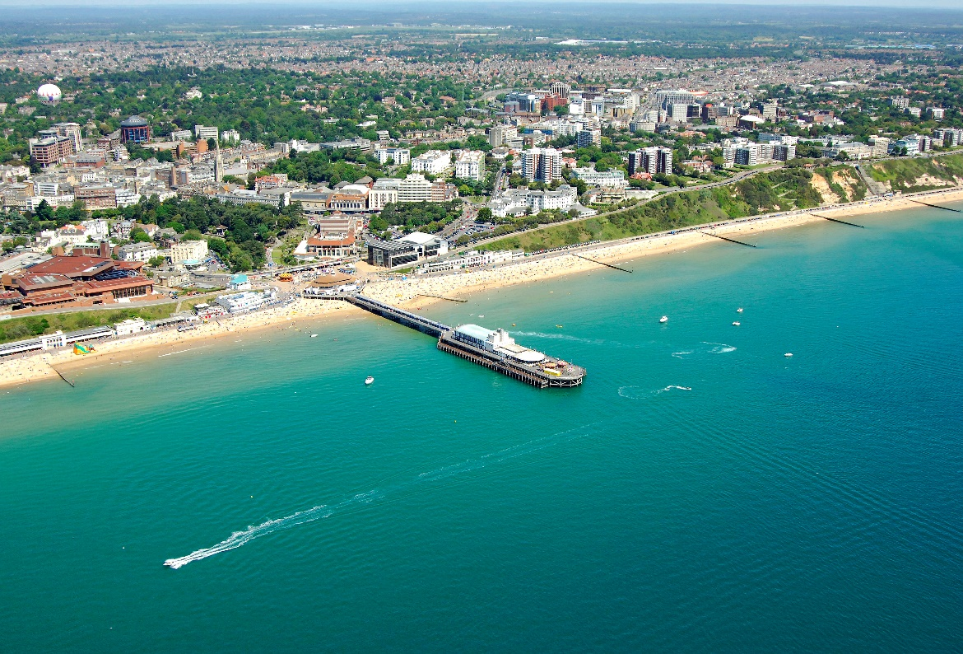

Employee Benefits
- Annual leave entitlement of 50 working days including bank holidays.
- Personal Pension with an employer contribution and the option of salary exchange.
- Instrument Insurance, through Allianz.
- Access to the BSO’s health and wellbeing programme.
- Medical cover from Medicash, a cash plan scheme providing money for a large range of treatments (see BSO health plan for details).
- Life Insurance which provides a life cover of 3 times salary.
- Employee discount and cash back scheme on high street brands and companies.
- Complimentary or reduced-price tickets to BSO concerts and theatre/cinema at the Lighthouse when available.

