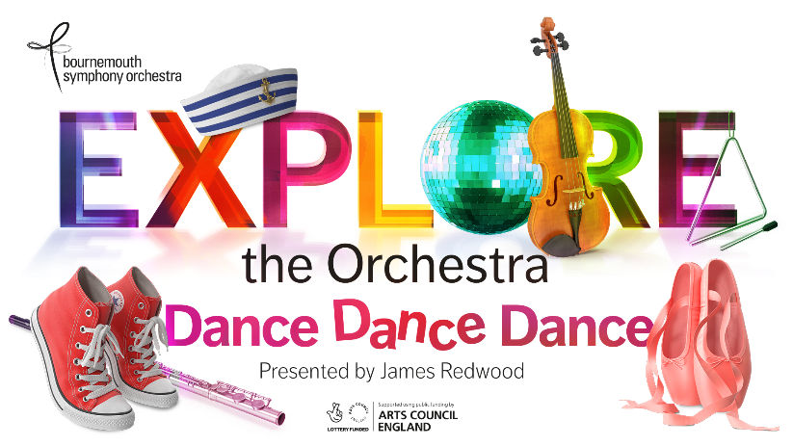

I Wanna Dance! (Lyrics)

CHORUS
I wanna dance, dance, dance,
Don’t let the lights go down.
I wanna move, move, move,
I need to get that dancing crown!

Let’s move up, up, up,
Throw your hands high in the air!
We’re going to groove and party like we just don’t care!

Verse 1
When I hear the music I’m a star in a different dimension,
Let my body flow - every move is a new invention.
Like a bird, soaring through the sky,
I’m a crackling fire, I’m as light as a butterfly.

CHORUS

Verse 2
Oh so beautiful – this is a celebration,
An adventurer – I am an inspiration.
I’m a firework, a piece of dynamite!
I’m a firework, a piece of dynamite!
I shine like a diamond…

CHORUS
I wanna dance, dance, dance etc.

