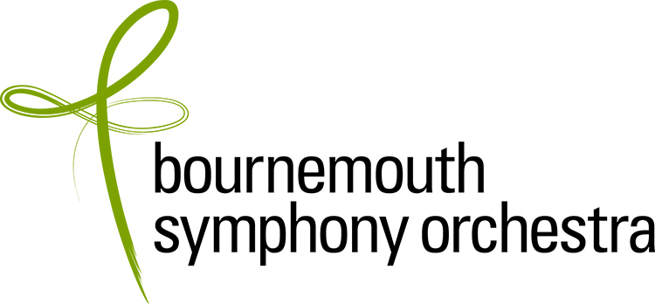

AUDITION APPLICATION FORM

Applications should be emailed to: efisher@bsorchestra.co.uk Please complete all sections

Data Protection: The information that you have given in this form will be held for recruitment purposes only and will not be disclosed outside the BSO without your permission.

BSO can only accept applications from candidates who are eligible to work in the UK at the time of application. It is your responsibility to ensure that you have the correct documentation, including a work permit if applicable.

APPLICANTS ARE REQUIRED TO SEND A SCANNED COPY OF THEIR WORK PERMIT OR PROOF OF SETTLED STATUS WITH THIS APPLICATION FORM.

POSITION APPLIED FOR | 2nd Clarinet, doubling bass

CLOSING DATE FOR APPLICATIONS: Thursday 31 March 2022
(Applications received after the closing date will be considered at the Company’s discretion)

Surname |  | Title
Other names

PERSONAL DETAILS (please complete all sections)
Full home address
Postcode |  | Country
Phone / mobile |  | Diary Service (if applicable)
Email |  | National Insurance Number
Nationality |  | Are you eligible to work in the UK? | Yes / No  (Note: if you do not hold a British passport, you must include proof of settled status or visa with your application)
Have you ever been convicted of a criminal offence, other than motoring offences & spent convictions?  (declaration subject to the Rehabilitation of Offenders Act 1974) |  | Yes / No
BSO is committed to equality & diversity in employment. If you have any accessibility requirements please tell us about the adjustments we need to make to assist you at audition.

AUDITION APPLICATION: Education and Experience (this section will be sent separately to the panel, hence a further request for your name and the position for which you are applying)

Name:

Position applied for: | 2nd Clarinet, doubling bass (closing date: 31 March 2022)

ORCHESTRAL EXPERIENCE
Please list details of your orchestral experience, stating position where applicable.
Please start with the most recent and include dates.
Orchestra | Position (if applicable) | Dates

MUSICAL EDUCATION AND TRAINING

Institution | Study/degree course | Dates | Qualification obtained

TEACHERS

Name | Dates

ADDITIONAL INFORMATION
Please use this space to provide any additional information that is relevant to your application, for example: details of solo/chamber music performances, master classes, competitions etc.

How did you hear about this vacancy? Please tick all that apply.
Musicalchairs ☐
BSO Website ☐
BSO Instagram ☐
BSO Twitter ☐
BSO Facebook ☐
BSO LinkedIn ☐
Word of Mouth ☐

Other (please specify) ☐

Declaration:

- If you are offered the position you will be required to complete a medical questionnaire.

- On taking up your post you will be required to undergo a hearing check as part of the induction process.

- If you are offered the position you will be required to undergo a DBS (Disclosure & Barring Service) check.

- Do not include a CV with your application.

I can confirm that to the best of my knowledge the above information is correct. I accept that deliberately providing false information could result in my dismissal.

Name:
Date:

Note: if you do not hold a British passport, you must include proof of settled status or visa with your application

Without this information we are unable take your application further.

