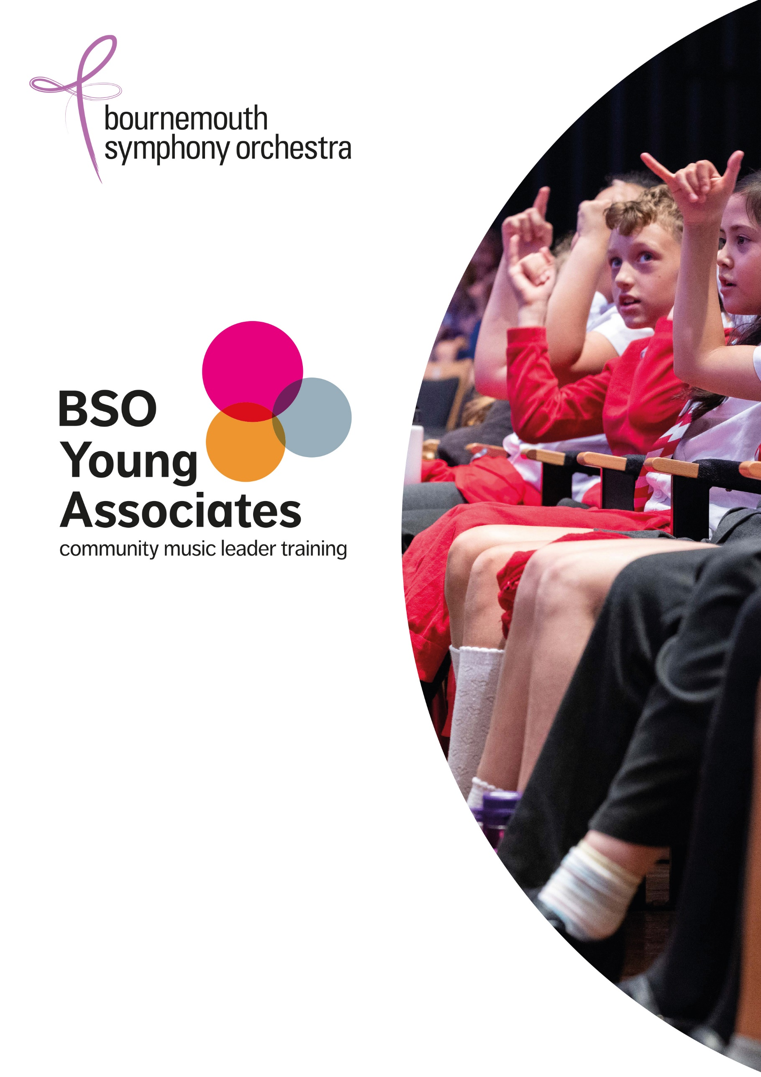
Information for Applicants 2023-24

List of contents
- About this programme
- Who we are looking for
- How does it work?
- How to apply
- Example of BSO Participate projects

Passionate about music? Keen to inspire and make a difference? Become a community music leader with BSO’s Young Associates Scheme.

The BSO Young Associates is an opportunity for 18-26 year olds from backgrounds underrepresented in the arts and based in the South West to train as community music leaders. If you’re creative, passionate about music of all kinds and love working with people, then the 9-month part time BSO Young Associate scheme will give you paid experience, training and mentoring to inspire others as a community music leader. No music leading experience required – we’re looking for potential!

About the BSO Championing culture in people’s lives
One of the UK’s best-loved orchestras, Bournemouth Symphony Orchestra is a professional ensemble known for championing the role of culture in people’s lives. With residencies in Bournemouth, Bristol, Exeter, Portsmouth, Poole and Yeovil, it is the largest cultural provider in the South West, serving one of the biggest regions. Challenging barriers to high-quality music for all, the BSO is committed to improving equality, diversity and inclusion in classical music, in our workforce and leadership.

About this programme
The BSO Young Associates programme provides a career springboard for two talented young people to develop skills as music leaders through practical experience, training and mentoring.
Running from mid-September 2023 – June 2024 the programme combines:
- Practical experience on a wide range of BSO learning & community music projects across the South West region
- A training & development plan tailored to each Young Associate
- One-to-one mentoring from an experienced music leader
- The chance to develop and deliver your own project with the BSO
Successful applicants will receive a £10,000 bursary paid in regular payments each month, from September 2023 to June 2024. Participants will need to commit up to 10 days a month to the programme. The programme will be scheduled around other work and music commitments.
What is a music leader?
A music leader is someone who leads creative music projects with people of all ages, from all walks of life, often for social, health or wellbeing goals or to enrich creativity and learning. They could work in all sorts of different settings, from community spaces to schools, hospitals and residential care homes, facilitating music-making with people with a wide range of musical experience and confidence. You don’t need to have music leading experience to apply, we’re looking for people with potential.
Who we are looking for
We’re looking for people with the potential to be a great communicator, connect with people from all walks of life, and take their musical and creative skills to the next level. No music leading experience necessary but to apply to be a BSO Young Associate you must:
- Be a musician, vocalist, music producer, composer, sound artist, MC or songwriter of any genre
- Play music to a high standard
- Embrace different styles of music and be keen to learn new skills
- Be passionate about music making with people of all ages, abilities and needs
- To be based in the South or South West of England
Created to support those who are underrepresented in the arts, the programme is for musicians aged 18 – 26 (although applicants aged up to 30 can be considered) who are:

- from lower income backgrounds
- of Global Majority heritage
- identify as disabled, D/deaf or Neurodivergent
We recognise that applicants may face other barriers not specified here, including the challenges of rural isolation in the South West. There is space in the application form to detail this if you would like.

How does it work?
The nine-month learning & development programme will be tailored to the Young Associates’ needs and interests, consisting of:
- Hands-on experience on BSO music projects, which could include presenting, music workshop leading and co-creative music making
- Regular mentoring by a BSO Associate musician
- The equivalent of 16 days tailored training from BSO Associate musicians and other music specialists
- Behind the scenes experience across the BSO
- Planning and leading a creative project at the end of the programme (with a budget), coached and supported by the BSO team and BSO Associates
Commitment
Participants will need to commit to up to 10 days a month to the programme for projects, training and mentoring. Activities will take place all around the South West, and projects are scheduled a few months ahead.
The programme will work around Young Associates’ other work commitments, and there are likely to be busier and quieter periods depending on the schedule of projects.
Bursary & Expenses
The £10,000 bursary will be paid in equal monthly payments.
Travel expenses agreed in advance will be reimbursed in addition to the bursary, and overnight accommodation will be paid for by BSO where required. Young Associates will need to travel to projects and events across the South West from Cornwall to Bristol and Southampton.
Please contact Jess Craig jcraig@bsorchestra.co.uk or 07860 268847 if you would like to chat to us about any access requirements.

How to apply
- Complete the application form downloadable from the webpage www.bsolive.com/jobs/young-associates.
- Email completed applications (including video/audio clips if applicable) to Catherine Thomas on participate@bsorchestra.co.uk by Friday 14 July 2023, 5pm.
In the application form we will ask about you as a musician and why you want to do the programme. Please cover the points below in your answers:
  - Tell us about you as a musician (max 500 words or video/audio clip)
    - Your musical experience, skills, interests and training
    - Any professional work you’ve done
    - Your passion for communicating and working with people
    - Workshop or music leading experience (not essential!)
    - Links to your music and music projects online
  - Tell us why you want to do the programme (max 500 words or video/audio clip)
    - Why is community music making important to you?
    - What are you hoping to get out of the programme?
    - Is there any specific mentoring/training you’re hoping for?
    - What are your long-term goals in your career?
As this is a targeted programme it also includes questions based on guidance from the Social Mobility Commission, and around Protected Characteristics as outlined in the Equality Act 2010. Please share whatever information you feel comfortable with and you can select "prefer not to say" if you would rather not answer any question.
Please note: Your answers will be held as strictly confidential and used for internal purposes only.

Shortlisted applicants will be invited to an interview/audition on Tuesday 25 or Wednesday 26 July in Poole. If you are successful there may be second round of interviews in person or on zoom to be confirmed on either Tuesday 31st July or Wednesday 1st August. The first round of interview/auditions will involve:
- An informal interview
- A whole-group music workshop
- A chance to meet other young musicians
Your travel expenses will be reimbursed for attending this interview day. Please note there may be a photographer/videographer at the audition day. Please get in touch if you have any concerns regarding this.
If you have any questions about the programme or would like to find out more please can along to our ‘Meet a Music Leader online Q&A’ on Tuesday 4 July at 4pm. Email Catherine Thomas on participate@bsorchestra.co.uk if you would like to attend.

If you would like more information or a friendly confidential chat about any aspect of the programme before applying, please contact Jess Craig jcraig@bsorchestra.co.uk to arrange a phone call. We look forward to receiving your application.

Example of BSO Participate projects
There are a wide range of projects you could be involved with, for example:
Recovery Orchestra (Health & wellbeing)
A recovery orchestra for people living with addiction in partnership with Bristol Drugs Project. The Recovery Orchestra provides a space for people to experience and connect through music in a safe and supportive environment with people who have similar shared experiences.

Explore the Orchestra co-creative workshops (School project)
A project in primary school settings with the aim of co-creating a song to be featured in the KS2 symphonic schools concerts.

Aubergines Family Orchestra (Community & families)
A multi-generational family project working with people from multiple musical tastes and genres. Aiming to create their own music through a collaborative process.

On your Doorstep concerts (Ensembles)
Opportunity to present these small ensemble and rural concerts, some aimed at family audiences.

While the arts should reflect the UK’s richly diverse society some communities are not equally represented. “Only 16 percent of the creative workforce are from working class social origins, compared to just under one-third across the whole UK economy” (Carey et al, 2020, 2021b) Taken from Creative Majority Report, APPG (September 2021): https://www.kcl.ac.uk/cultural/resources/reports/creative-majority-report-v2.pdf
In line with the Social Mobility Commission (Socio-economic Diversity and Inclusion. Toolkit: Creative industries (publishing.service.gov.uk)

