BSO@Home Tech FAQs

How do I make my video player full screen?
If you hover over the video with your mouse, at the bottom right of your video player there is an icon with four arrows. Click on this and it will make your video full screen. To go back to your original size, click on these four arrows again to close the full screen or alternatively press the ‘esc’ button on your keyboard.

How do I turn up the audio level?
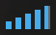
If you hover over the video with your mouse, at the bottom right of your video player there is an icon with five vertical bars. Click on the highest bar to reach full volume on your device. If you are connected to a Hi-Fi/Bluetooth speaker or your Television, be sure to increase the volume on your primary device first before adjusting on your main speaker.

What should my device requirements be?
To watch an event on Livestream, please ensure you have the following:
System Requirements:
Windows 7 or higher,
Mac OS X 10.6 or higher
Apple Device
Android Device
Amazon Fire TV / Tablet

What supported browsers can I use?
To watch an event on Livestream, please ensure you have the following:
Supported desktop browsers:
Google Chrome 45+
Mozilla Firefox 49+
Safari 10+
Microsoft Edge 15+
Supported mobile browsers:
Chrome 45+,
Safari 10+ (iOS)
Amazon Silk

How do I get the best internet connection?
5-10mbps download speed is recommended. Check your connection at www.speedtest.net.
On desktops, we recommend that you use an Ethernet cable from your Broadband router to your PC rather than using a wireless connection.

Why does my video keep buffering?
Many factors can influence video playback, including some that pertain to your computer or device. If you’re not getting the best viewing experience on Vimeo, you might want to try these simple fixes.

Switch to “Auto” in the quality menu, if available.
Auto mode automatically adjusts to the best quality of video for your current Internet connection and processing speed. We recommend using this default setting to avoid buffering delays. (If “Auto” is not available, switch to one of the lower quality options.)

Disable any browser extensions, plugins, or add ons
Third party programs can sometimes cause issues during playback— including blocked video segments, dropped frames, buffering, etc. If you're having trouble, try disabling any active extensions one-by-one to find the culprit. You can also open your video within an incognito or private window of your browser for testing.

Restart your router and modem
Resetting your router or modem can help to refresh your connection and improve playback performance. Try disconnecting the power cord and then reconnecting to perform a hard reboot.

Update your browser
Browser software is constantly being improved upon. Make sure you are using the latest version of your browser for peak performance. The latest version of each browser can be found here.

Close excess browser tabs or applications
Keeping too many applications open can make everything run slower, including video playback. Especially on a mobile device, it’s easy to forget which apps are running. Make sure that you completely close or disable apps instead of just minimizing their windows.

Clear your browser’s cache
Although this may sound simple, refreshing your cache can help with many different issues, including playback. Learn more here.

Disable/Enable Hardware acceleration
Hardware acceleration makes resource-hungry operations run more efficiently, but sometimes doesn’t work well with older graphics cards. Try disabling or enabling this option within your browser settings.

Can I use a chromecast?
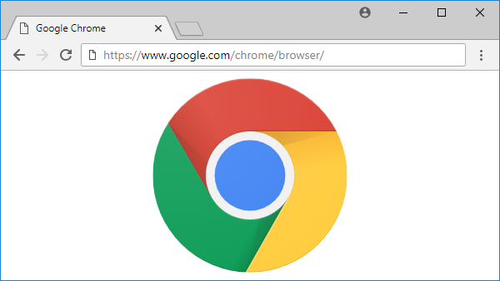
At the moment we do not support simple casting from a mobile device, only from a PC where you can cast the whole Google Chrome tab. You can use Chromecast if you cast from your PC. You need to cast the whole Chrome browser tab – you need to click on the 3 little dots in the top right corner and then click on cast so that you can find and connect to the dongle if you are in wireless range.

We are working with Vimeo to see if they might soon develop casting from the embedded video on our website. You will need to purchase a Chromecast dongle which you can then plug into a spare HDMI socket on your TV.

Where can I use the chat function?
Below the video player there is a chat box where people can join the video chat room and comment on the event. Type in your name to start the conversation. The chat is moderated so please be respectful and kind to others in the Live Stream Chat or you will be removed.

Why does it say ‘The Event has not started yet’?
The livestream video will appear with a countdown from 7pm. We then join the atmosphere of the concert hall from just after 7.15pm with our live presenter and pre-concert artist interviews. If the screen still says this message, please refresh your browser and the video should start.

Can I rewind the Live Stream?
Unfortunately, you can’t rewind the stream when it’s being broadcasted live. However, you can rewind on the video once it has been broadcasted and it is available for 30 days.

How do I change the quality of my stream?
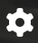
If you are experiencing buffering (when you get interrupted video or sound) we suggest that you change the Vimeo stream settings by clicking on the button that looks like a cog and changing from auto to either 720p or 540p.

Is there a lag between real life and the online live event?
Yes, there is a time delay that will be seen on the online live event.

