Information for Applicants

Development Assistant

Contents Page

Foreword from the Chief Executive 3
Development Assistant Job Description and Person Specification 4-5
About Bournemouth Symphony Orchestra 6
Organisational Structure 7
How to Apply 8

Foreword from the Chief Executive

I have an unshakeable belief that music has the power to change people’s lives. I have personally witnessed it.
You will be joining a highly committed team of people who work hard to support each other in helping to realise the Bournemouth Symphony Orchestra’s ambition to ‘enhance lives through music’.
I joined the BSO almost 8 years ago because of its high artistic values, outstanding Principal Conductor and international reputation. Its tradition of world-class music making had captured the respect and regard of audiences both nationally and internationally.
Since then, the BSO has gone from strength to strength,
However, I am also personally passionate about the excellent programme of education and community engagement BSO has established over the last 25 years. The impact of its work has ensured BSO’s passage to the very heart of the social fabric and regional identity of the South West.
There is a great fundraising story to be told about this incredible organisation. I hope you will join us.

Dougie Scarfe
Chief Executive

JOB DESCRIPTION

Title: Development Assistant

Reports to: Development Manager (Membership and Legacies)

Responsible for: N/A

Main Purpose of Job
The Development team is responsible for the fulfilment of the fundraising needs of the Bournemouth Symphony Orchestra (BSO). Working to set targets, the team generate funds through various income streams including trusts and foundations, corporate partnerships, major donors, legacies and through the BSO’s membership scheme. This is an exciting opportunity to gain experience and develop skills underpinning the fundraising discipline including event co-ordination, supporter care, marketing, donor communications and data analysis to gain real experience in the stewardship and management of BSO members and legacy pledgers.
Key Areas of Responsibility

- Support the Development Manager and Head of Department in the implementation of the membership and legacy strategies.
- Act as a helpful and professional first point of contact for members, donors and legacy pledgers, by phone, email, post and in person at events.
- Financial processing of membership renewals and donations, including one-off and regular transactions made via Direct Debit and continuous payment authority.
- Maintain accurate records for members and legacy pledgers on our central database (Spektrix), including recording donations, event attendance, thank you letters and other correspondence.
- Run regular reports from the database to establish membership activity and trends.
- Using the database, administer all aspects of the membership scheme, including coordinating monthly membership renewals, reminders for lapsed members, new member welcome packs and distribution of our supporter magazine ‘Quarternote’ and the annual review.
- Assist the Development Manager with the production of new materials including the annual membership events leaflet, welcome packs, mailings, display material etc. Duties may include writing copy, proof-reading and design.
- To produce, update, maintain and oversee the team’s annual events planning documents (including on BSO’s website) and to diarise events and the team’s attendance.
- Support, deliver and attend cultivation and stewardship events across our main concert hubs, principally Poole, Portsmouth and Exeter. Duties will include preparing guest lists, issuing invitations, writing staff briefings, and administering room bookings, musician attendance and hospitality requirements (with venues and caterers).
- Attend pre-concert and occasional post-concert events for members, legacy pledgers, donors and prospective supporters, acting as a representative of the Orchestra and Development team
- Export and analyse audience and supporter data from the database, enabling the team to identify potential new members, legacy pledgers and supporters.
- Support the Development Manager by undertaking research and data analysis of new and existing donors, members and prospects to identify potential interest in BSO’s work.
- Identify with relevant colleagues those members and legacy pledgers who have the capacity to be upgraded to higher levels of support.
- Work with the Finance team to ensure that payments are processed promptly, accurate records of income and expenditure for members are maintained, and that Gift Aid income is maximised.
- Provide administrative support for corporate partnerships work and corporate events as briefed by either the Head of Development or Development Manager (maximum 7 hours per week).

PERSON SPECIFICATION
Essential
- Interest in classical music, the arts and fundraising in a cultural organisation

- Education to degree level or equivalent

- Willingness to learn and apply that learning in the workplace

- Strong communication (written and oral) and inter-personal skills including a genuine enjoyment for meeting new people and building relationships

- Highly organised with experience of juggling competing priorities and hitting deadlines

- Meticulous attention to detail

- Team player

- Strong IT skills, including Microsoft Office (particularly Excel)

- Comfortable working with databases, handling data and data analysis

- A full, clean driving licence

Highly desirable
- Experience of event management

- Experience of working with CRM systems

About Bournemouth Symphony Orchestra
‘The cultural heartbeat of the South West.’ Darren Henley, Chief Executive of Arts Council England
Bournemouth Symphony Orchestra is a world-class ensemble known for spearheading change both on and off the stage since 1893.
The Orchestra is highly regarded for its ambitious programming and recordings, with its Prokofiev cycle and survey of Eastern European music under the baton of Chief Conductor Kirill Karabits receiving recent acclaim. The BSO serves a 10,000-square-mile region, touring around 140 performances each year to audiences in South West England and beyond. The BSO also offers a number of smaller ensembles, including BSO Resound, the disabled-led ensemble pushing the boundaries of performance practice, and Kokoro, a contemporary chamber ensemble.
A bold champion of new talent, the BSO boasts an enviable list of principal conductors, including Marin Alsop – the first female principal conductor of a major UK orchestra – Constantin Silvestri, Paavo Berglund and Andrew Litton. It has given memorable performances at Carnegie Hall, the Musikverein, and Rudolfinum, and gives regular live broadcasts on BBC Radio 3 and Classic FM.
A commissioner of new music, the BSO has worked with composers Mark Anthony Turnage, Sally Beamish and James Macmillan in recent years. Founded by Sir Dan Godfrey, the BSO has remained a cornerstone of British orchestral music; it welcomed Elgar, Holst, Ethel Smyth, Tippett and Vaughan Williams to the region, and counts Bartók, Rachmaninov, Sibelius and Stravinsky amongst past collaborators.
The BSO’s discography charts a number of landmark moments in 20th century music, including: pioneering 1914 recordings under Sir Dan Godfrey for HMV; seminal performances of Nordic works with Paavo Berglund in the 1970s; and a survey of American and Soviet works – under Litton, Alsop and Karabits – from the 1980s to the present day. Key recordings include: Elgar/Payne Symphony No.3 under Paul Daniel; Tchaikovsky’s Piano Concerto No.2 with Peter Donohoe, Nigel Kennedy and Steven Isserlis under the baton of Simon Rattle; Shostakovich and Glazunov with Nicola Benedetti; and Marin Alsop’s interpretation of Bernstein’s Chichester Psalms.
Empowering lives through the power of music remains at the core of all that the BSO does. As winner of the prestigious 2019 Royal Philharmonic Society Impact Award, the BSO was recognised for its work in improving opportunities for the next generation of disabled talent. It was Alzheimer’s Society’s ‘Dementia Friendly Organisation of the Year’ in 2017, before presenting the world’s first professional disabled-led ensemble, BSO Resound, at the BBC Proms in 2018. Known for its work in defining the modern symphony orchestra, BSO Participate – who work with all ages off the stage – is internationally recognised as an act to follow. Over 650 community workshops and events take place each year across the BSO’s vast region, enhancing thousands of lives each year.

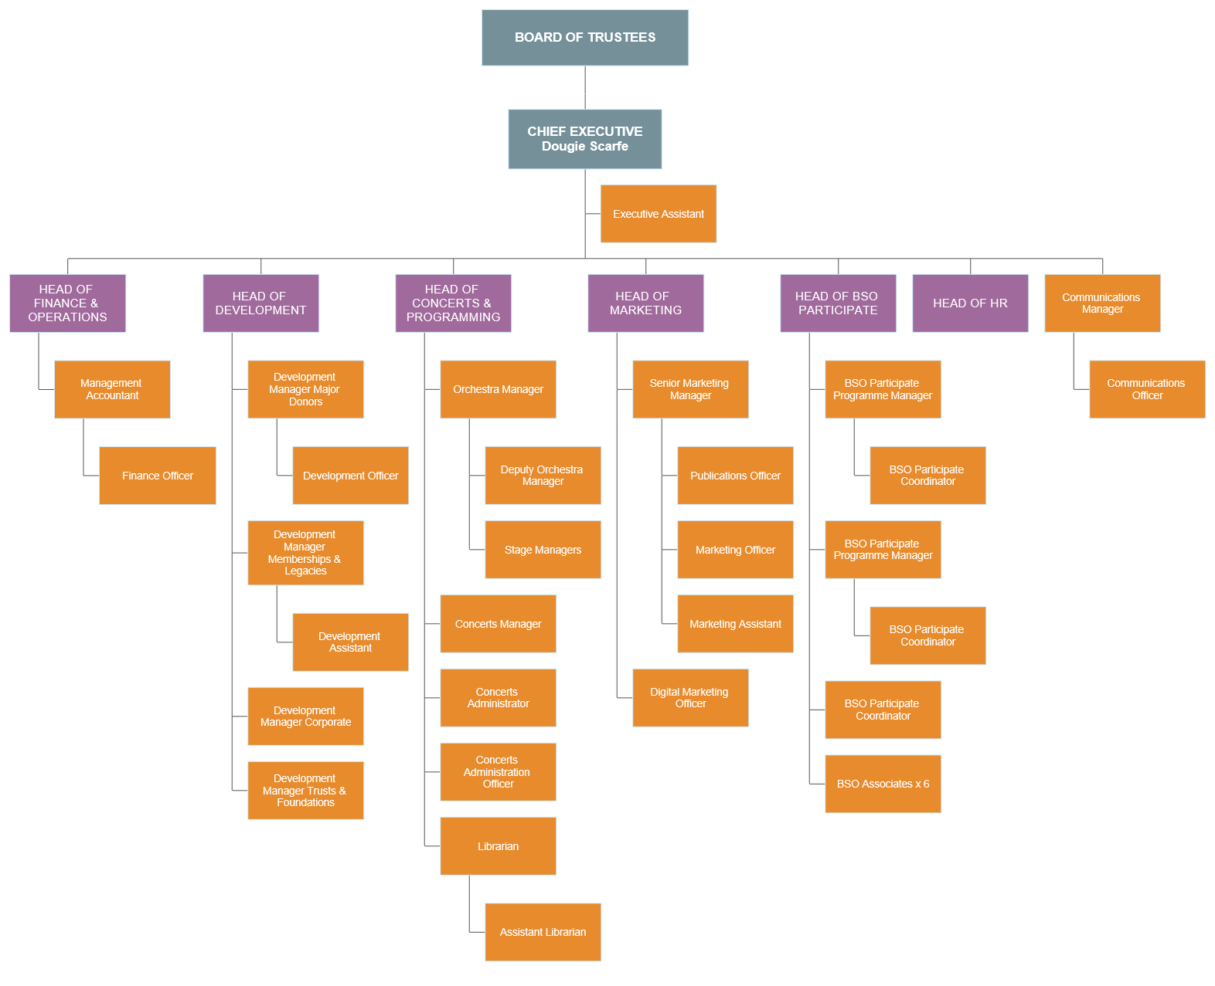

How to Apply

DEVELOPMENT ASSISTANT
circa. £18,000 per annum depending on experience
Bournemouth Symphony Orchestra (BSO) is now recognised as one of the most dynamic orchestras in the UK, with its distinguished history, commitment to high artistic ideals and trail-blazing work using the power of music to change lives both within the concert hall and beyond.
This is an opportunity for a bright and confident team player to take a first step into a successful fundraising team at a major arts organisation which is big on ambition, as well as being a creative and a great place to work.
You’ll be a central figure in the Development team supporting the varied work we undertake to develop relationships and inspire support for our work. As the ‘go to’ person for the team you’ll support a broad range of tasks giving you great exposure into the inner workings of a busy fundraising team. You’ll be the first point of contact for our BSO members and responsible for a variety of work including event co-ordination and delivery, creation and distribution of supporter communications, marketing and data analysis.
This is more than an assistant role; this is an opportunity to assume real responsibility in support of the expansion of the Orchestra’s membership scheme and legacy programme, building relationships, managing communications and delivering specific events for valued supporters in Poole, Portsmouth, Exeter and across the region.
Experience in fundraising is not essential. What we’re really after is someone who loves music and what BSO does. We need someone who is good with people, has strong IT skills, is willing to learn and understands the value that organisational skills and attention to detail can add to the experience of our members and supporters.
We know that amazing people are hard to come by so we invest in our staff’s learning and development, making sure people are given opportunities to shine. You’ll receive benefits including complimentary tickets to BSO concerts, shows and films at Lighthouse Centre for the Arts, access to BSO’s health and wellbeing programme, life insurance, personal pension, 20 days annual leave plus bank holidays and a discretionary quota of leave between Christmas and New Year.
An application form is available on the BSO website at www.bsolive.com/careers which should be sent with your CV and a covering letter to Natalie Wright at nwright@bsorchestra.co.uk
Closing date: Monday 13th January 2020 at 5.00pm
Date for Interviews: Friday 17th January

BSO is an equal opportunities employer

